Portfolio
Name: Raghav Maharjan
Student ID: 2548924

LINK: https://raghavmjn10.github.io/Workshop2/
Repo link: https://github.com/raghavmjn10/Workshop2/

HTML CODE: 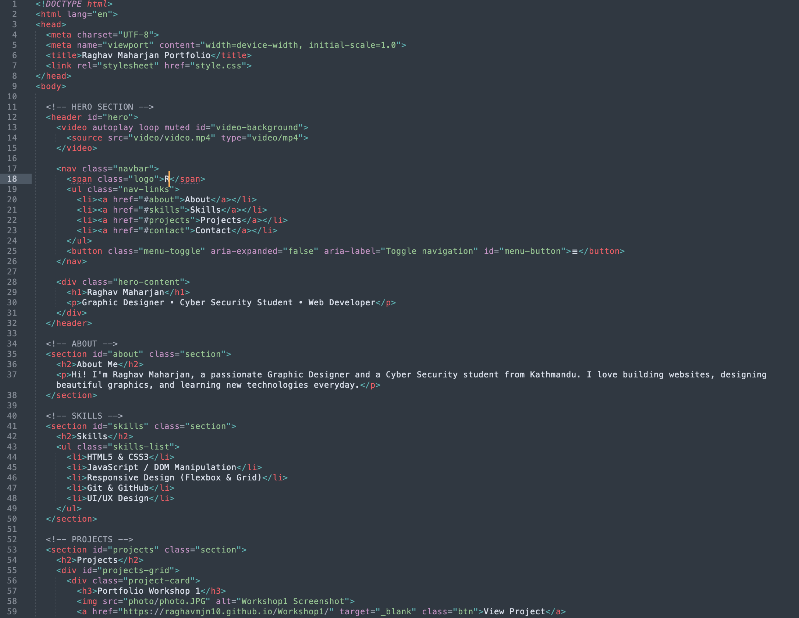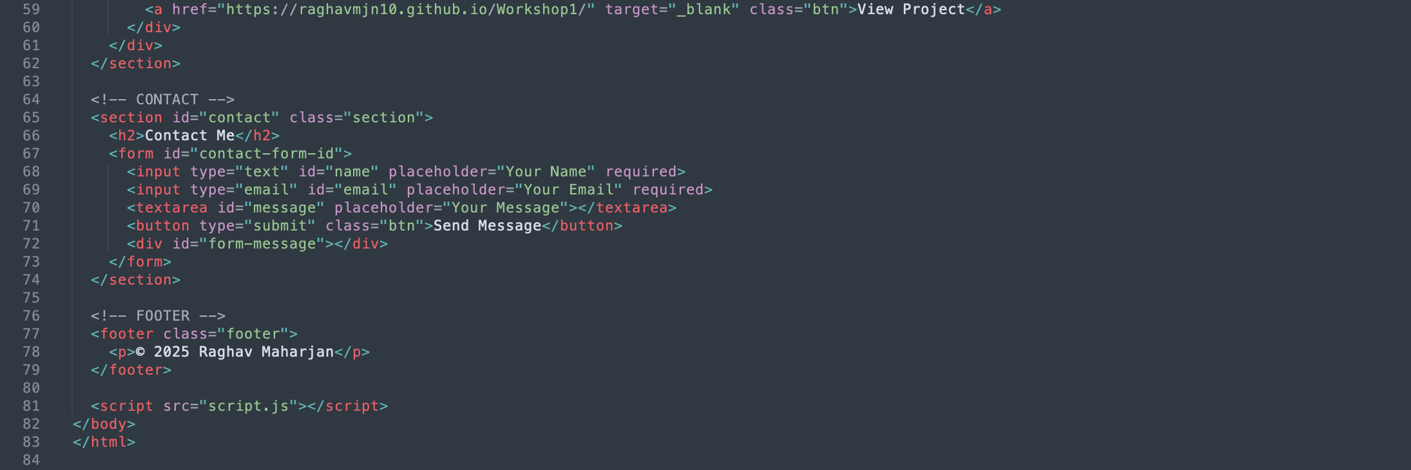
CSS CODE: 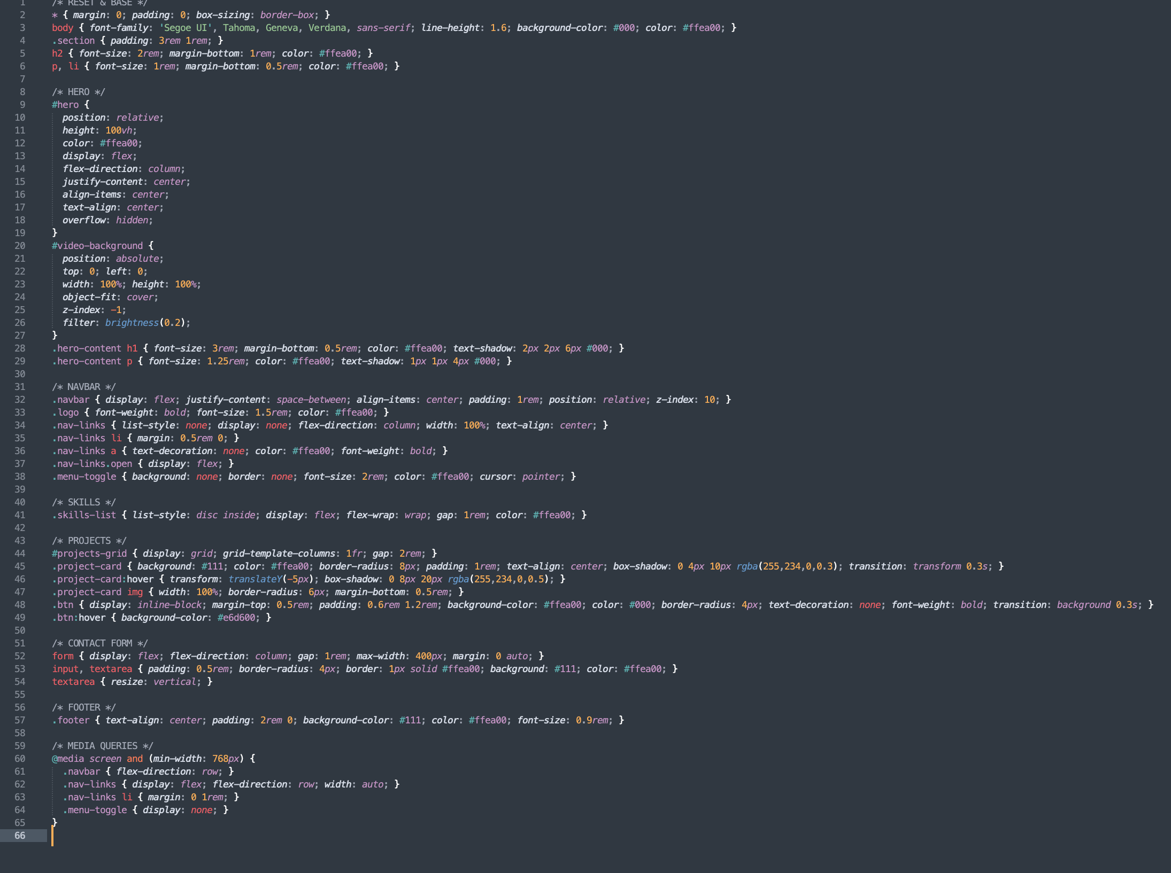
JavaScript code: 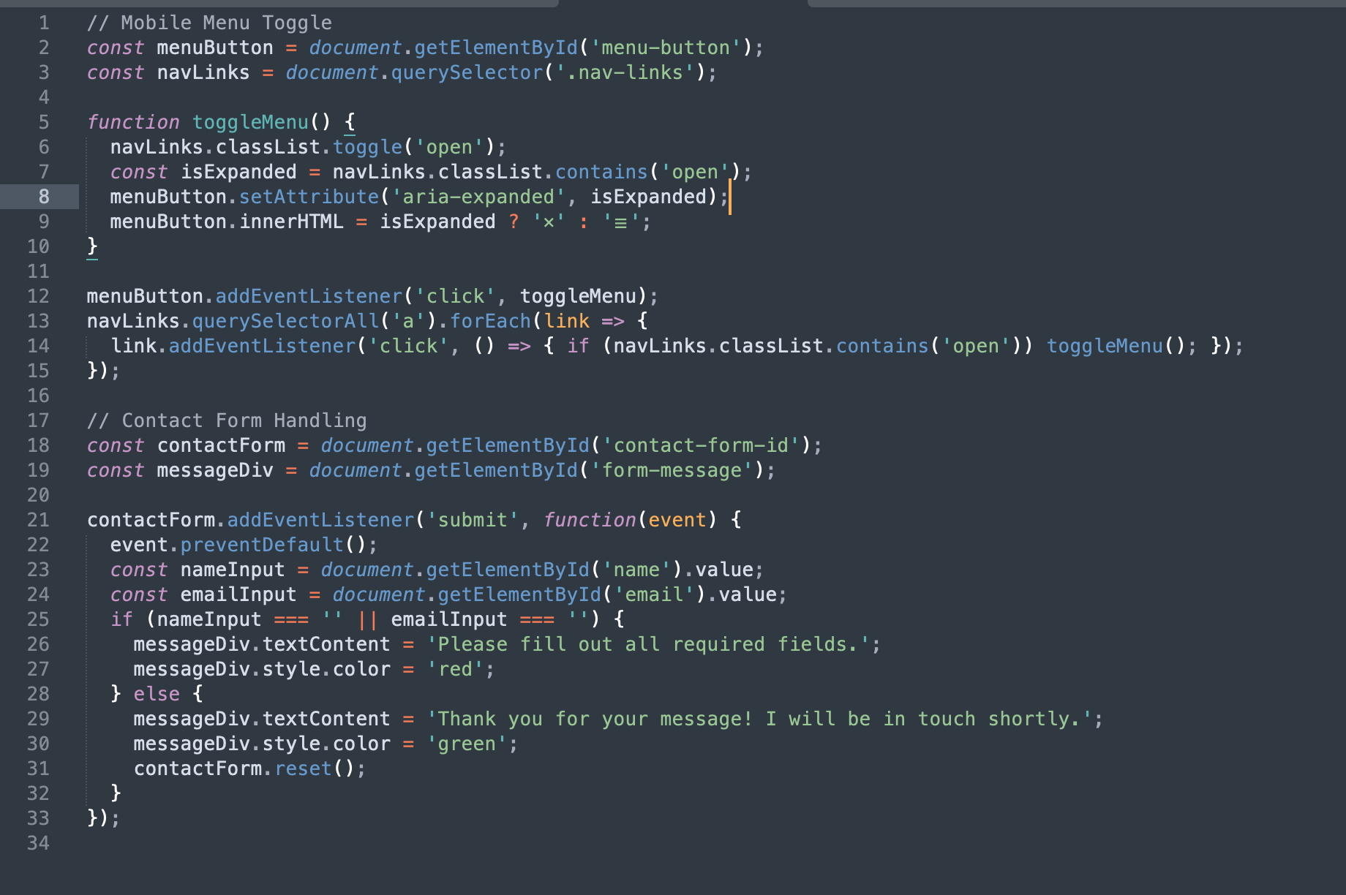
PORTFOLIO SCREENSHOT: 